Nacre Software Services Pvt. Ltd.
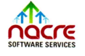
July 01, 2021
Hyderabad

TO WHOMSOEVER IT MAY CONCERN
This is to certify that Mr. Saiprakash Beemari was a trainee with Nacre Software Services Pvt Ltd., from 28 October 2019 to 30 September 2020.
During his tenure his performance was good. We found him self-motivated and enthusiastic and he has taken part in the mentoring programme with good dedication and learning spirit. He area of expertise is in .NET Technology. His skills set includes C#.NET,ASP.NET, HTML, CSS and JAVA SCRIPT.
We wish him the very best in his future endeavors.
Yours Sincerely,
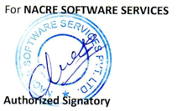


# 7-1-212/A/69, Plot No:84, Shivabagh, Ameerpet, Hyderabad - 38, Tel: +91-404015 1017 email: info@nacreservices.com www.nacreservices.com

